I360: File Structure Worksheet

*How does your web browser see files?*

**Understanding the URL**

*Identify the following:*  
  
folders • web server (computer) • HTML file •  query string

http://www.iub.edu/campus-tour/sample-gates.html

http://boingboing.net/2013/10/17/everybody-knows-youre-a-do.html

http://www.nytimes.com/2016/01/24/technology/an-app-helps-teachers-track-student-attendance.html?ref=technology

http://alistapart.com/

http://www.starbucks.com/store-locator/search/location/Bloomington%2C%20IN%2C%20USA

**Understanding Project File Structure**

To go down a level: use forward slash “**/**” (meaning directory) to indicate a folder  
To go up a level: use two dots “**..**” to indicate going up one level from current directory

Base URL = **file:///Users/erikalee/Desktop/EXERCISE/**

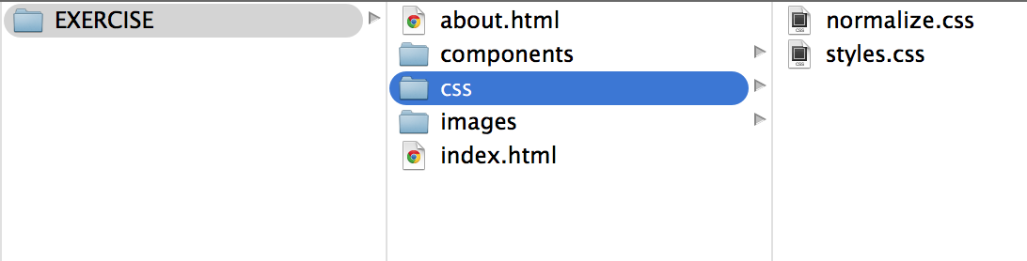

**(a) What is the full LOCAL PATHNAME for *index.html* on this computer?** (This is the location for the file ON THIS PARTICULAR COMPUTER)

**file:///Users/erikalee/Desktop/EXERCISE/index.html**

**(b) Now imagine the middle column is the ROOT directory for a website “**[**http://www.website.com**](http://www.i399.com)**”, what would the URL be to the file *index.html*?**(This is the location for the file ON THE WEB)

**http://www.website.com/**

**(c) Still working with website.com... What’s the URL to *about.html*?**

**http://www.website.com/about.html**

**(d) Write the <link> from *index.html* to your stylesheet *styles.css:***

**<link href="css/styles.css" rel="stylesheet">**

**(e) Write <img> tag in *index.html* that points to the image *kittens.jpg,* which lives in the *images* folder:**

<img src=”images/kittens.jpg” alt=”kitten”>

**(f) Write a <a> link in *index.html* that points to *about.html:***

**<a href=”about.html”>About Page</a>**

**(g) Add a style in *styles.css* that adds *kittens.jpg* as a background image:**(How would you reference an image in the “images” folder from within “styles.css,” which lives in the “css” folder?)

**header {**

**background-image: url(“/images/kittens.jpg”);**

**}**



**(h) Okay, now that you have the hang of this, try these:**

1. Write the tag to display an image of a squirrel (squirrel.jpg) in index.html.

<img src=”images/squirrel.jpg” alt=”Squirrel”>

1. To add a background image we reference the image from the CSS in our styles.css. The background won’t show up as currently written because the pathname is wrong. What is the correct pathname to reference an image (acorns.jpg) within the images folder from styles.css?

**html {**

**background-image: url(“/images/acorns.jpg”);**

**}**